PROGRAMING FUNDAMENTAL (theory)

A.HANNAN
SU92-BSSEM-177

TASK 1:

#include<iostream>
using namespace std;

int main()
{
int r, c;
cin >> r >> c;

int a[10][10];
int sum = 0;

for(int i=0; i<r; i++)
{
for(int j=0; j<c; j++)
{
cin >> a[i][j];
}
}

for(int i=0; i<r; i++)
{
for(int j=0; j<c; j++)
{
sum = sum + a[i][j];
}
}

cout << sum;

return 0;
}
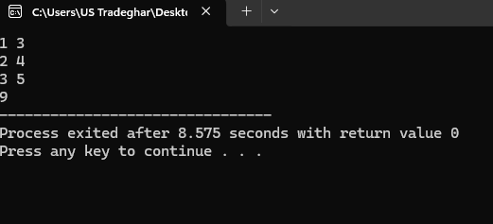

Task 2
#include<iostream>
using namespace std;

int main()
{
int r, c;
cin >> r >> c;

int a[10][10];

for(int i=0; i<r; i++)
{
for(int j=0; j<c; j++)
{
cin >> a[i][j];
}
}

int result = a[0][0];

for(int i=0; i<r; i++)
{
for(int j=0; j<c; j++)
{
if(i==0 && j==0)
{
continue;
}

result = result - a[i][j];
}
}

cout << result;

return 0;
}
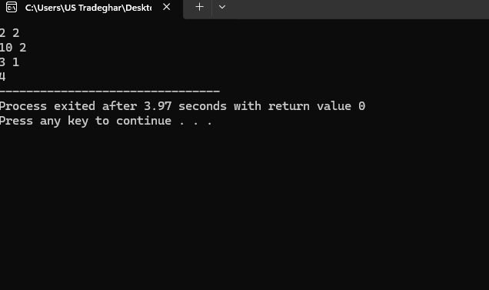
Task 3
#include<iostream>
using namespace std;

double calculateArea(double s)
{
return s * s;
}

double calculateArea(double l, double w)
{
return l * w;
}

int main()
{
double side, length, width;

cin >> side;
cin >> length >> width;

cout << "Area of Square: " << calculateArea(side) << endl;
cout << "Area of Rectangle: " << calculateArea(length, width);

return 0;
}
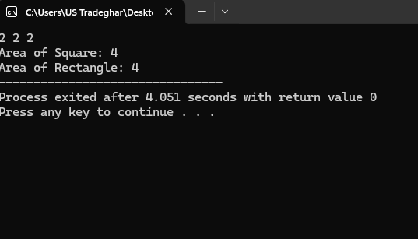
Task 4
#include<iostream>
using namespace std;

double getBowlingAverage(int runs, int wickets)
{
if(wickets==0)
{
return 0;
}

return (double)runs / wickets;
}

int main()
{
int runs, wickets;

cin >> runs >> wickets;

cout << "Bowling Average: " << getBowlingAverage(runs, wickets);

return 0;
}
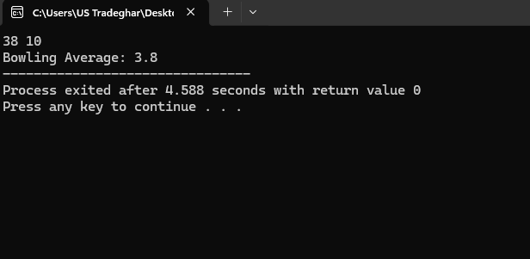
Task 5
#include<iostream>
using namespace std;

void printWord(char word[], int size)
{
for(int i=0; i<size; i++)
{
cout << word[i] << endl;
}
}

int main()
{
char word[20];
cin >> word;

int size = 0;

while(word[size] != '\0')
{
size++;
}

printWord(word, size);

return 0;
}
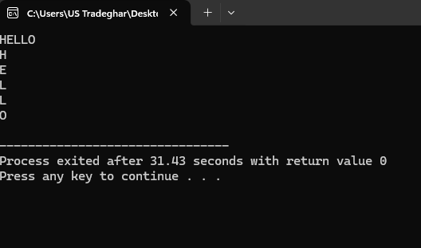
Task 6
#include<iostream>
using namespace std;

void reverseWord(char word[], int size)
{
int i = 0;
int j = size - 1;

while(i < j)
{
char temp = word[i];
word[i] = word[j];
word[j] = temp;

i++;
j--;
}
}

int main()
{
char word[20];
cin >> word;

int size = 0;

while(word[size] != '\0')
{
size++;
}

reverseWord(word, size);

cout << "Reversed Word: " << word;

return 0;
}
